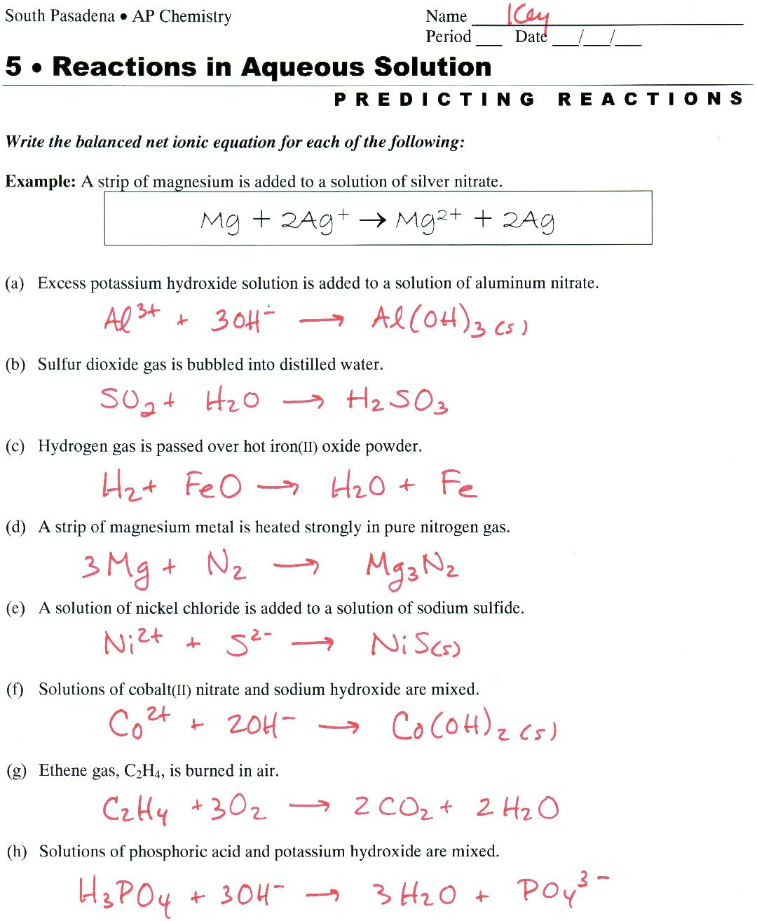

Notes:
(a) This is a double replacement reaction forming a precipitate. Both of the reactant substances are soluble, so K⁺ and NO₃⁻ are eliminated as spectator ions.

(b) Oxides of nonmetals form acids in water. Note: Don’t be confused by gas-formation reactions. When H₂SO₃ is formed by double replacement, it decomposes. This is not double replacement. Only a small amount of H₂SO₃ is formed and can stay in solution.

(c) This is oxidation reduction. H₂ must turn into a compound. So… elemental H (oxidation number 0) must change to +1. Therefore, something must be reduced. The Fe²⁺ in FeO is reduced to metallic Fe. The H⁺ combines with the O²⁻ to form H₂O.

(d) Elemental Mg must turn into Mg²⁺. This is oxidation-reduction. Since Mg is oxidized, the N₂ must be reduced. From its position on the periodic table, N must change to N³⁻ (nitride… see your green sheet). The two ions combine to form the strange compound, Mg₃N₂.

(e) Double replacement forming a precipitate. Na⁺ and Cl⁻ are spectator ions.

(f) Double replacement forming a precipitate. Na⁺ and NO₃⁻ are spectator ions.

(g) Combustion.

(h) Double replacement forming the weak electrolyte, H₂O. Since H₃PO₄ is a weak acid, it is written in the undissociated form. K⁺ is a spectator ion.

